A Project Report

On

# Analysis of Underlying Equity Asset & Equity Futures Instrument

BY

#### Group 22

Under the supervision of

#### Dr Nagaraju Thota

**SUBMITTED IN PARTIAL FULFILMENT OF THE REQUIREMENTS OF**

#### FIN F311: Derivatives & Risk Management



**BIRLA INSTITUTE OF TECHNOLOGY AND SCIENCE PILANI (RAJASTHAN)**

#### HYDERABAD CAMPUS

**(April 2021**)

# ACKNOWLEDGEMENT

We would like to express our sincere gratitude to Dr Nagaraju Thota for giving us this opportunity to work under him for this project and take his valuable time to provide us with invaluable inputs wherever required. His information proved to be very vital for this project. We would like to thank him and the Birla Institute of Technology and Science, Pilani, for giving us such an excellent opportunity to apply our course knowledge to a real-life scenario and get some hands-on experience. We are thankful for all his help and guidance throughout the course and this assignment.

# GROUP DETAILS

**Group 22**

|  |  |  |  |
| --- | --- | --- | --- |
| **S.No** | **Name** | **ID.No** | **Contributed (Yes/No)** |
| 1 | Akarshit Mohapatra | 2019A2PS1511H | Yes |
| 2 | Sreenivasapuram Krishna Prajwal | 2019A4PS0834H | Yes |
| 3 | Aayush Ambarish Tiwari | 2019A4PS0695H | Yes |
| 4 | Bibin Varghese | 2017ABPS1592H | Yes |
| 5 | Mayank Sureka | 2019A4PS0668H | Yes |

·

**INSTRUMENT DETAILS**

|  |  |  |
| --- | --- | --- |
| **Sr. Number** | **Instrument Name** | **Symbol** |
| 1 | Cholamandalam Investment and Finance Company | CHOLAFIN |

# ABSTRACT

The project mainly aims to make recommendations about Cholamandalam Investment and Finance Company Ltd. This is accomplished by analysing the spot and future prices of the company for one year from March 2 2020, to March 26 2021. A quick introduction explaining the nature of business, structure of ownership, influence on the market and its overall importance is provided for the company as mentioned above.

As this fulfils the qualitative analysis, thorough quantitative analysis is provided through the comparison of returns. The returns on Equity were measured and plotted on a graph against daily, weekly, and monthly dates. The returns were then adjusted for risk by deducting the T-Bill rate for the same frequency to provide a more realistic view. This shows the excess returns gained over the risk-free return. Sharpe Ratio was computed to understand the excess return per unit of risk undertaken.

Following this are the tabular formatted Mean Return, Maximum Return, Minimum Return, and Standard Deviation. A comparable procedure was then employed to understand the equity derivatives of such stocks. Futures price was obtained from the clearing house for daily, weekly, and monthly frequencies for the near month, next month and far month expiry dates. The returns were then adjusted for risk by deducting the T Bill rate for the same frequency to make it more realistic, and it shows the excess return gained over the risk-free return. Monthly frequency Far Month Future contracts generated the highest return amongst both Equity and futures.

Further, a comparison has been made between equity returns and futures returns. Then, the overall liquidity position of Equity and futures has been discussed. A note on Contango and Backwardation has also been provided to analyse the difference between futures price and spot price. Thus, this report seeks to understand returns through various financial instruments, find their portfolio risk and suggest the best investment strategy.

# TABLE OF CONTENTS

ACKNOWLEDGEMENT 2

GROUP DETAILS 3

ABSTRACT 4

SECTION -1 7

* 1. Introduction To Underlying Equity Asset 7
     1. Nature of Business 7
     2. Ownership 7
     3. Origin of the Company 8
     4. Industrial Significance 9
     5. Overall greatness of CHOLAFIN 9
  2. Unadjusted Risk Returns for Underlying Equity Asset 10
  3. Risk-Adjusted Returns for Underlying Equity Asset 12
  4. Economic Interpretation 14

SECTION - 2 17

* 1. Introduction To Equity Futures Instrument 17
     1. Introduction 17
     2. Overall Greatness of the Equity Futures Instrument 18
  2. Unadjusted Risk Returns for Equity Futures Instrument 19
  3. Risk-Adjusted Returns for Equity Futures Instrument 25
  4. Risk-Adjusted v/s Unadjusted Returns for Equity Futures Instrument 31
  5. Economic Interpretation 38

SECTION - 3 39

* 1. Comparison of Unadjusted & Adjusted Returns 39
  2. Liquidity Position 41

SECTION - 4 42

* 1. Contango and Backwardation 42
  2. Significance of Frequency 44

SECTION - 5 45

5.1 Conclusion 45

SECTION 6 46

* 1. References 46

CHOLAMANDALAM INVESTMENT and FINANCE COMPANY LTD.



#### Note:

* + - All the prices used are in Indian National Rupee (INR).
    - The terminology used: Current month is written as Near month; Middle month is written as Next month.
    - Appropriate references have been cited wherever necessary.
    - The returns (unadjusted/adjusted) have been expressed in terms of percentage.

# SECTION -1

### Introduction To Underlying Equity Asset

### Nature of Business

Cholamandalam Investment and Finance Company Ltd (CIFLC) is an investment banking and financial services firm operating with verticals across finance, IB, insurance, mortgages, and stockbroking.

### Ownership

Cholamandalam investment and finance company ltd. (NSE: CHOLAFIN) is a publicly traded company with 7000+ plus employees; it has a presence all over the nation. Mr Arun Alagappan heads the company as the managing director of the Murugappa group.

|  |  |  |
| --- | --- | --- |
| **Holder’s Name** | **No. of Shares** | **% Share Holding** |
| **No. of Shares** | 820035129 | 100% |
| **Promoters** | 423285058 | 51.62% |
| **Foreign Institutions** | 135219517 | 16.49% |
| **N Banks Mutual Funds** | 166299302 | 20.28% |
| **Others** | 13030437 | 1.59% |
| **General Public** | 48111741 | 5.87% |
| **Financial Institutions** | 34076184 | 4.16% |
| **Foreign Promoter** | 12890 | 0% |

*Table 1: Cholamandalam Investment and Finance Company ownership details*

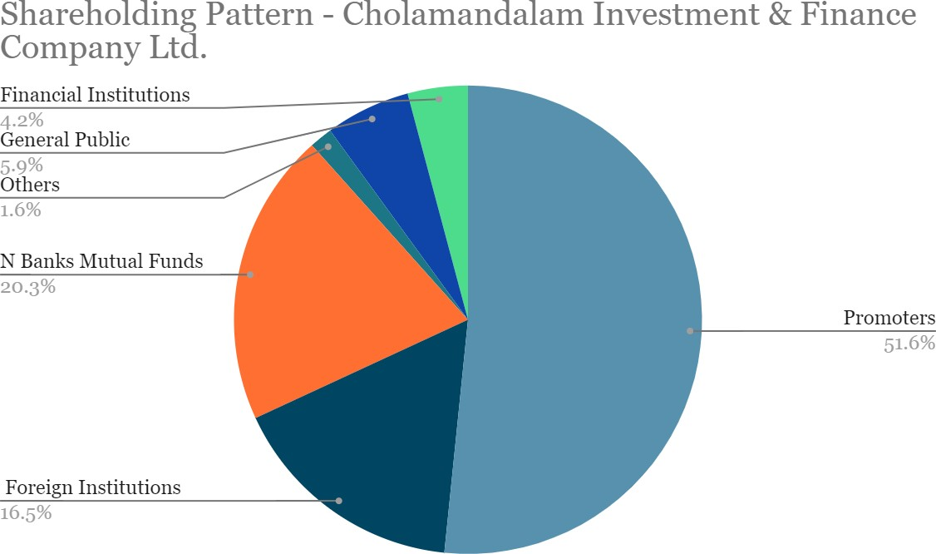

*Figure 1: Cholamandalam Investment and Finance Company shareholding*

### Origin of the Company

CIFLC got established in 1978 with its headquarters in Chennai, Tamil Nadu. CIFLC started as an equipment lending firm and has evolved into a full-service financial services company that provides vehicle funding, home loans, home equity loans, SME loans, securities management services, stockbroking, and various other financial services to its clients.

The board of directors of CIFLC are stated below for your reference.

#### Board of Directors:

|  |  |
| --- | --- |
| **Name** | **Designation** |
| **Arun Alagappan** | Managing Director |
| **Ashok Kumar Barat** | Independent Director |
| **Bhama Krishnamurthy** | Independent Director |
| **D Arul Selvan** | Chief Financial Officer |
| **M M Murugappan** | Chairman & Non-Exe.Director |
| **N Ramesh Rajan** | Independent Director |
| **P Sujatha** | Co. Secretary & Compl. Officer |
| **Ravindra Kumar Kundu** | Executive Director |
| **Rohan Verma** | Independent Director |

*Table 2: Cholamandalam Investment and Finance Company Board of Directors details*

### Industrial Significance

Cholafin operates from 1098 branches across India with assets under management worth above INR 63,501 Crores. Cholamandalam Securities Limited (CSEC) and Cholamandalam Home Finance Limited (CHFL) are the subsidiaries of Cholafin.

### Overall greatness of CHOLAFIN

The company has rapid earnings growth and a low payout ratio making it possible to re-invest in its business. It has also seen a steady increase in its profit margin amid the COVID 19 pandemic, which has boosted the confidence of its shareholders. Moreover, it has an impressive stock-up of over 201% over the last five years and has a healthy earnings per share (EPS) ratio.

### Unadjusted Risk Returns for Underlying Equity Asset

|  |  |  |  |
| --- | --- | --- | --- |
| **Returns (Frequency)** | **Daily** | **Weekly** | **Monthly** |
| **Mean(%)** | 0.3416 | 1.7163 | 5.3590 |
| **Maximum(%)** | 15.5172 | 31.8094 | 32.6395 |
| **Minimum(%)** | -29.5990 | -40.4074 | -49.3874 |
| **Standard Deviation** | 4.8786 | 11.2848 | 20.2464 |

*Table 3: Unadjusted Risk returns for Equity*

* **Daily Returns**

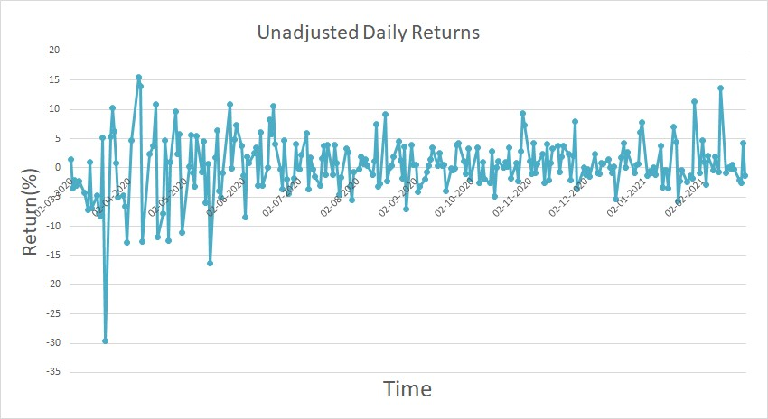

* **Weekly Returns**

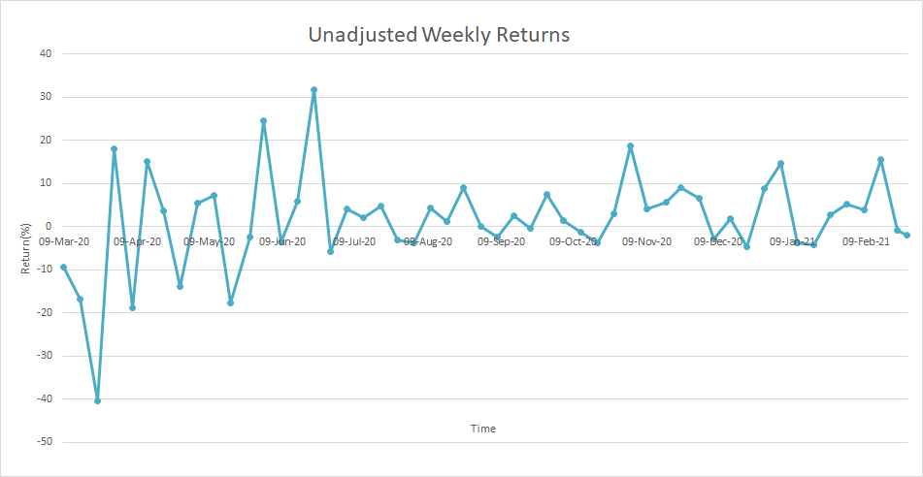

* **Monthly Returns**

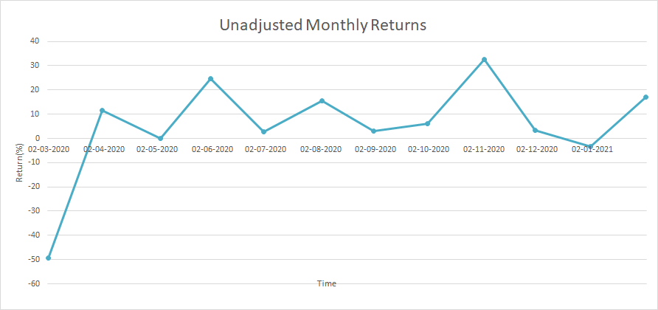

### Risk-Adjusted Returns for Underlying Equity Asset

|  |  |  |  |
| --- | --- | --- | --- |
| **Returns (Frequency)** | **Daily** | **Weekly** | **Monthly** |
| **Mean(%)** | 0.3252 | 1.6014 | 4.8614 |
| **Maximum(%)** | 15.4996 | 31.6969 | 32.1469 |
| **Minimum(%)** | -29.6164 | -40.5277 | -49.8989 |
| **Standard Deviation** | 4.8786 | 11.2856 | 20.2482 |

*Table 4: Adjusted Returns for Equity*

* **Daily Returns**

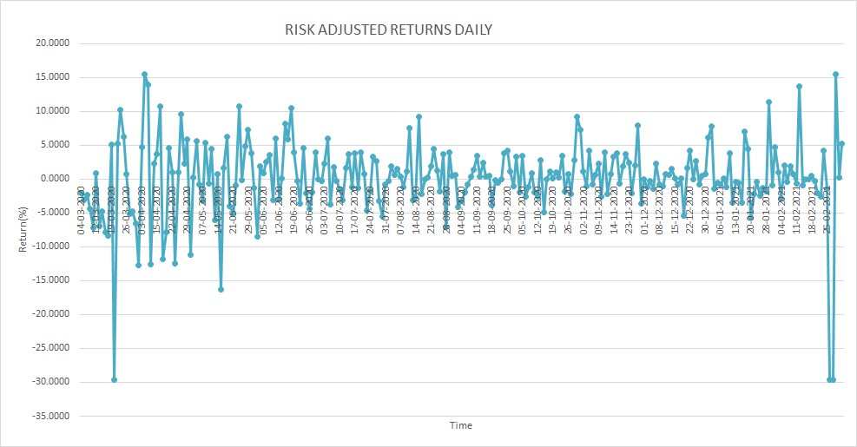

* **Weekly Returns**

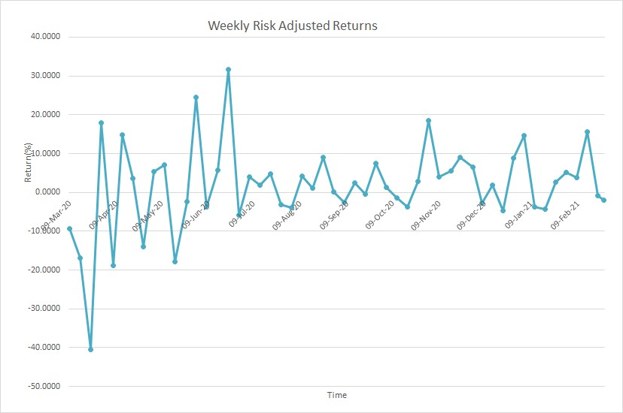

* **Monthly Returns**

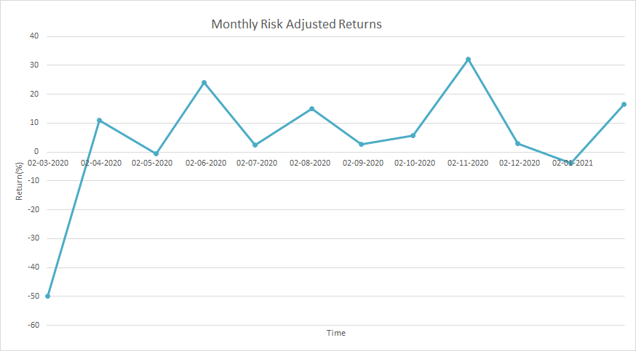

### Economic Interpretation

**Risk-Adjusted Return and Sharpe Ratio:**

Risk-adjusted return is defined as the return in excess of the risk-free return that can be made by investing in the asset. Hence, it is calculated by subtracting the risk-free return from the risk- unadjusted return.

*Sharpe ratio*, defined as the excess portfolio return over the risk-free rate relative to its standard deviation, is generally used to indicate the risk-adjusted return

* Sharpe Ratio = (rp - rf)/stdev(rx)
  + rp = risk-unadjusted return
  + rf = risk-free return/rate
  + rx = risk-adjusted return

The risk-adjusted returns are always lesser than the unadjusted risk returns since they are adjusted for the risk-free rate. Thus they are a more economically valuable indicator for comparing the returns on the asset. Risk-adjusted returns (instead of unadjusted risk returns) should be greater than risk-free returns to make the investment profitable. Otherwise, an investor can be better off by investing in a risk-free asset.

The following table shows the trend in the Sharpe ratio for equity investments with different frequencies:

|  |  |  |  |
| --- | --- | --- | --- |
| **Sharpe Ratio (Frequency)** | **Daily** | **Weekly** | **Monthly** |
| **Mean** | 0.0667 | 0.14191 | 0.2401 |
| **Maximum** | 3.1771 | 2.8088 | 1.5878 |
| **Minimum** | -6.0707 | -3.5913 | -2.4646 |
| **Standard Deviation** | 1.0000 | 1.0000 | 1.0000 |

*Table 5: Sharpe Ratio for Equity*

* **Daily Sharpe Ratio**

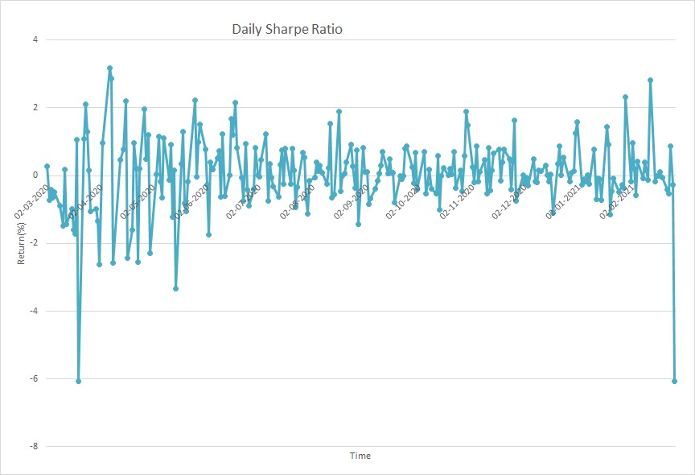

* **Weekly Sharpe Ratio**

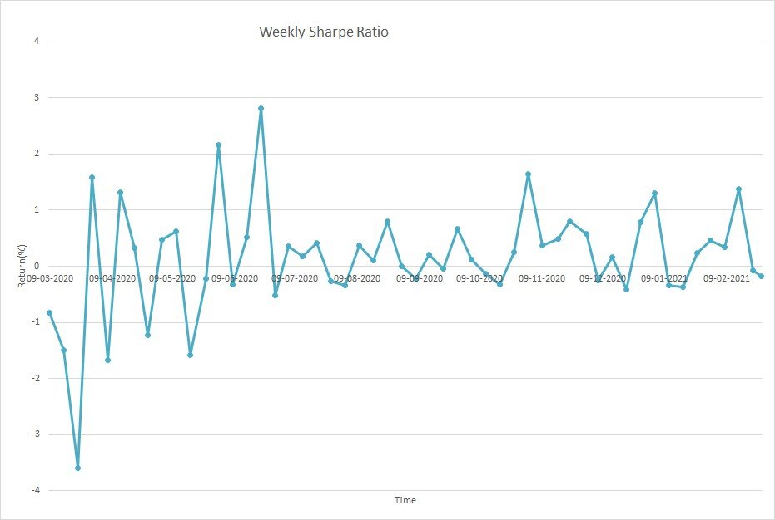

* **Monthly Sharpe Ratio**

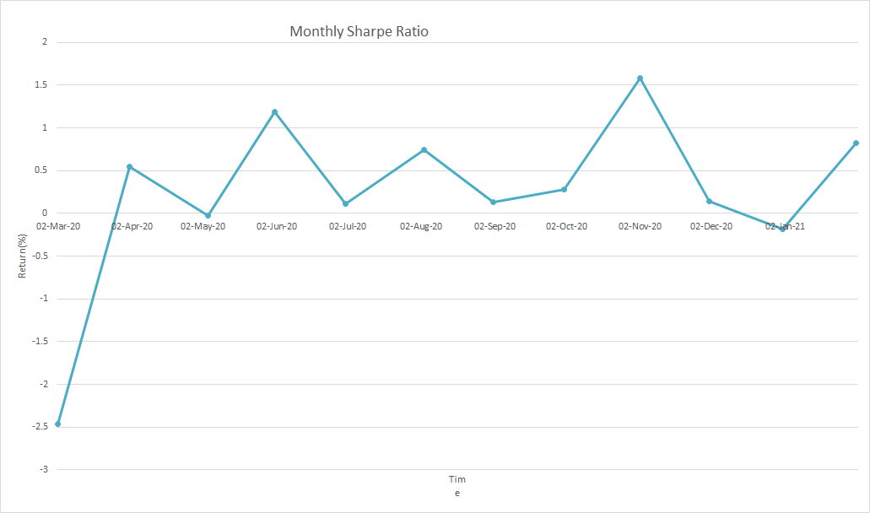

* **Sharpe Ratio v/s Frequency**

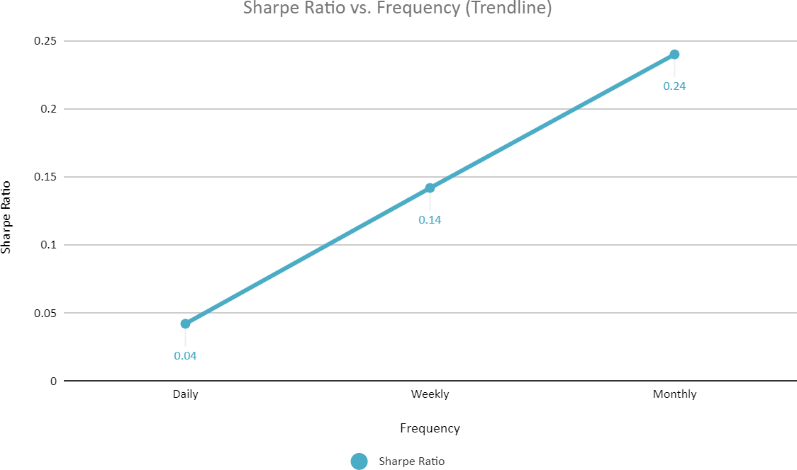

**Observations**

* The standard deviation, i.e. the volatility for the risk-adjusted and risk unadjusted data, are nearly similar.
* The mean returns for risk-adjusted and unadjusted data follow the trend: Monthly > Weekly

> Daily.

* The standard deviation for risk-adjusted and unadjusted returns follows the trend: Monthly

> Weekly > Daily.

* For risk- unadjusted returns, Sharpe Ratio follows the trend: Monthly > Weekly > Daily. A similar pattern is observed for risk-adjusted returns as well.

## Actions

* Risk loving investors can aim for monthly or yearly investments.
* We observe that the risk-adjusted return rises with increasing risk.
  + Thus, after adjusting for the risk, it may be best suited to go for longer-term positions in Cholamandalam Investment and Finance Ltd shares and avoid short term trades like intraday.
  + Given the recent financials and position of this firm in the sector, it may be safe to take the calculated risk of going for long term positions.
* Risk-averse investors can opt for investment in the spot market as the daily returns have minimum risk compared to weekly or monthly trends.
* Based on the Sharpe ratio calculations, it is advisable to invest long-term in the CIFLC shares.

# SECTION - 2

### Introduction To Equity Futures Instrument

### Introduction

The trading in derivatives was started by the National Stock Exchange of India Limited (NSE), with the launch of index futures on June 12 2000. The futures contracts are based on the Nifty 50 Index, a popular benchmark. The trading in Index Futures and Options (both based on Nifty 50) on individual securities was launched on November 9, 2001, and June 4, 2001, respectively. Futures and Options contracts on individual securities are available on more than 100 securities in 3 significant indices, specified by the Securities and Exchange Board of India (SEBI).

#### Futures Contract Details:

|  |  |
| --- | --- |
| **Ticker Symbol- NSE** | CHOLAFIN |
| **Instrument Type** | FUTSTK |
| **Underlying** | NIFTY |
| **Trading Cycle** | Near, Next, and Far Months |
| **Lot Size** | 2500 |
| **Final settlement basis** | Based on the closing price of underlying Equity on the last trading day of the contract |
| **Price Steps** | 0.05 INR |
| **Band operating price range** | 10% from the base price |

*Table 6: Future contract Details*

* If the last Thursday in the cycle is a trading holiday, the contract expires on the previous trading day.

### Overall Greatness of the Equity Futures Instrument:

The equity futures instrument is an essential instrument used by investors to speculate on stock prices, realise profits, and reduce their portfolio risk by hedging the portfolio.

Considering they have higher liquidity than equity stocks in the spot market, they play a significant role in any investor’s portfolio, looking to maximise profits or minimise their portfolio risk. Moreover, arbitrage opportunities can be exploited by investors.

### Unadjusted Risk Returns for Equity Futures Instrument

* + 1. **Near Month**

|  |  |  |  |
| --- | --- | --- | --- |
| **Returns(Frequency)** | **Daily** | **Weekly** | **Monthly** |
| **Mean(%)** | 0.3358 | 1.7162 | 12.2124 |
| **Maximum(%)** | 14.5675 | 29.8551 | 29.2380 |
| **Minimum(%)** | -29.7269 | -40.1683 | -4.8291 |
| **Standard Deviation** | 4.8553 | 11.0891 | 10.1225 |

*Table 7: Unadjusted Returns for Near Month Futures*

The following graphs show the risk - unadjusted returns for Near month CHOLAFIN Futures:

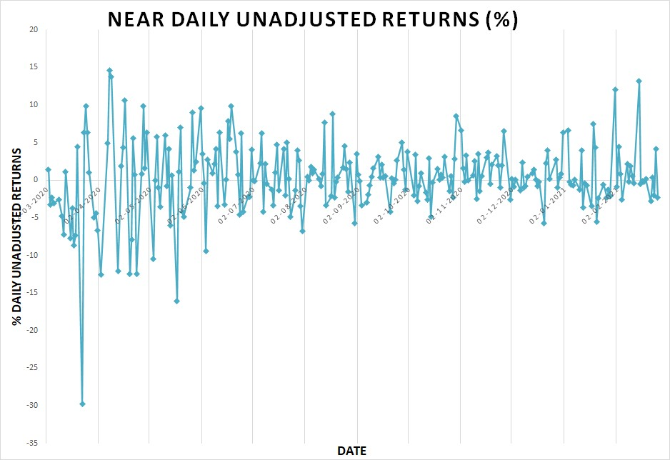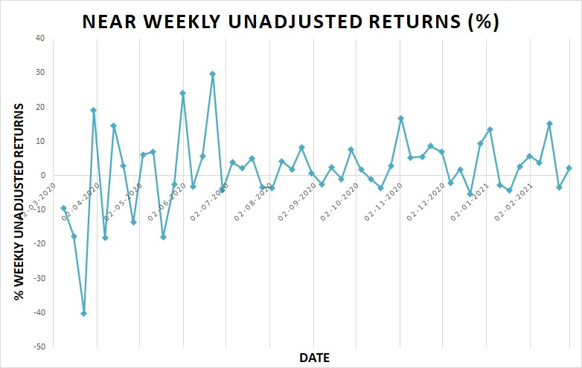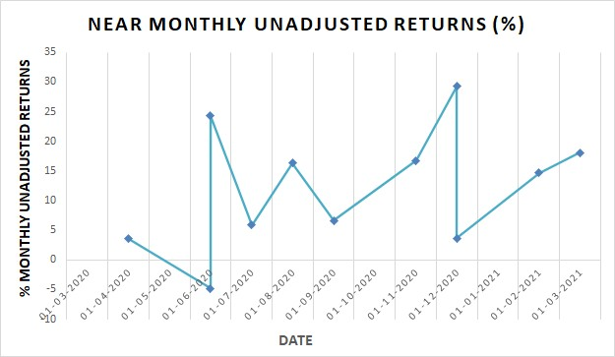

### Next Month

|  |  |  |  |
| --- | --- | --- | --- |
| **Returns(Frequency)** | **Daily** | **Weekly** | **Monthly** |
| **Mean(%)** | 0.3327 | 1.7036 | 12.1649 |
| **Maximum(%)** | 16.3685 | 27.4686 | 26.3854 |
| **Minimum(%)** | -28.7653 | -39.5704 | -4.2813 |
| **Standard Deviation** | 4.8846 | 11.1172 | 9.6075 |

*Table 8: Unadjusted Returns for Next Month Futures*

The following graphs show the risk - unadjusted returns for Next month CHOLAFIN Futures:

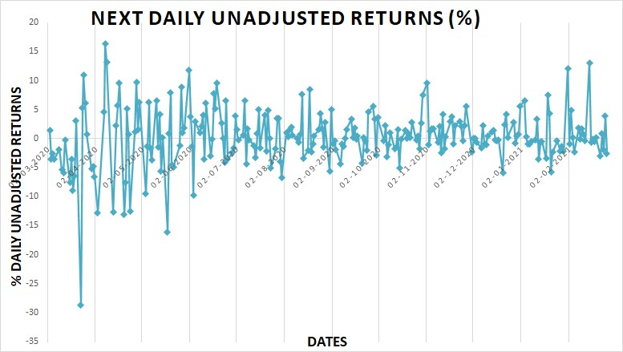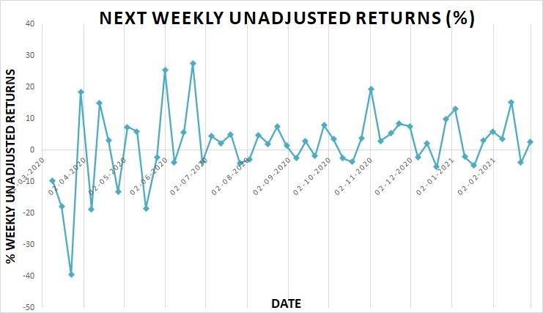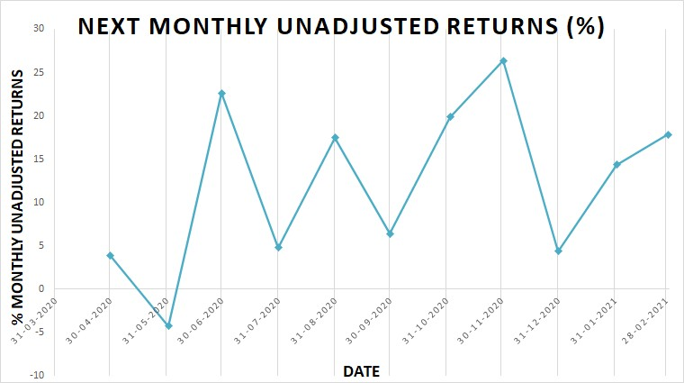

### Far Month

|  |  |  |  |
| --- | --- | --- | --- |
| **Returns(Frequency)** | **Daily** | **Weekly** | **Monthly** |
| **Mean(%)** | 0.3445 | 1.7307 | 12.2723 |
| **Maximum(%)** | 17.1093 | 26.0134 | 27.8669 |
| **Minimum(%)** | -29.8848 | -40.6846 | -4.3275 |
| **Standard Deviation** | 4.9555 | 11.1594 | 9.8340 |

*Table 9: Unadjusted Returns for Far Month Futures*

The following graphs show the risk - unadjusted returns for Far month CHOLAFIN Futures:

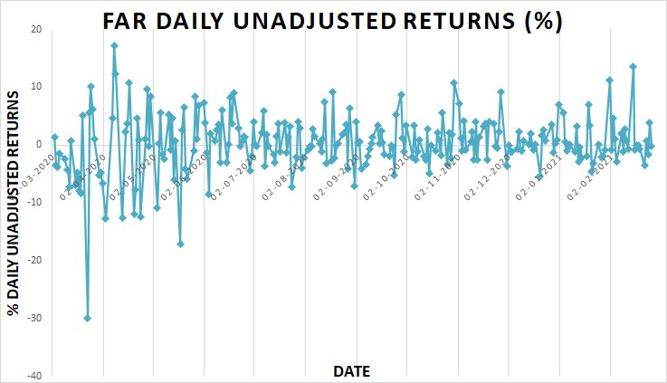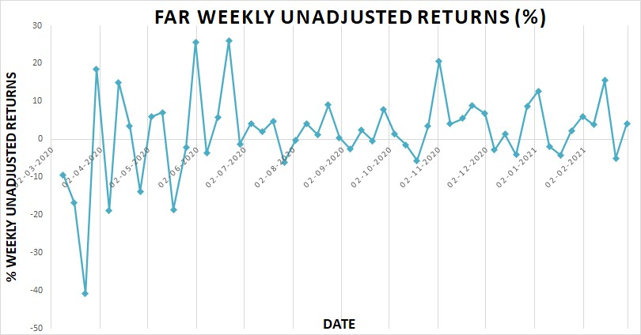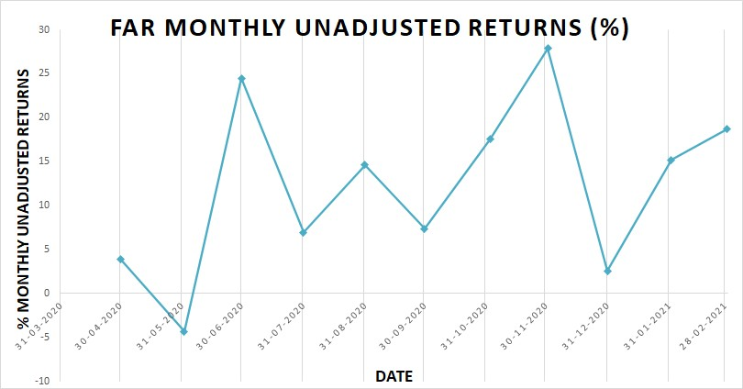

* 1. **Risk-Adjusted Returns for Equity Futures Instrument**

### Near Month

|  |  |  |  |
| --- | --- | --- | --- |
| **Returns(Frequency)** | **Daily** | **Weekly** | **Monthly** |
| **Mean(%)** | 0.3194 | 1.6013 | 11.7160 |
| **Maximum(%)** | 14.5499 | 29.7426 | 28.7454 |
| **Minimum(%)** | -29.7444 | -40.2887 | -5.3093 |
| **Standard Deviation** | 4.8553 | 11.0899 | 10.1197 |

*Table 10: Adjusted Returns for Near Month Futures*

The following graphs show the risk-adjusted returns for Near month CHOLAFIN Futures:

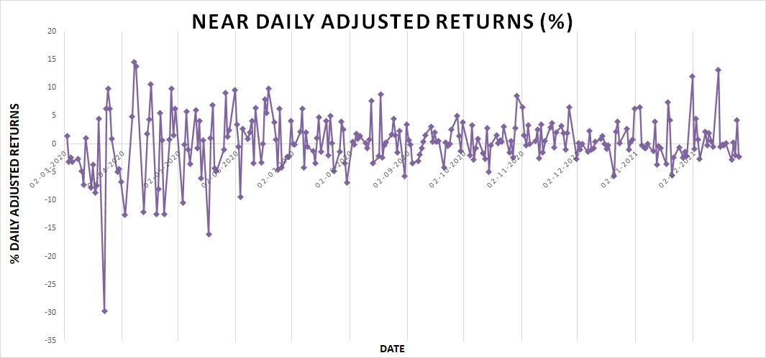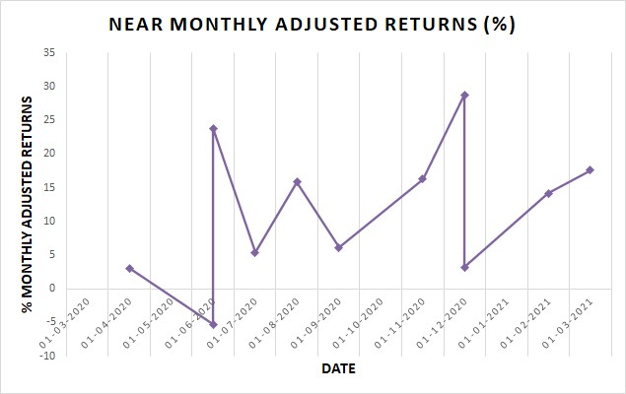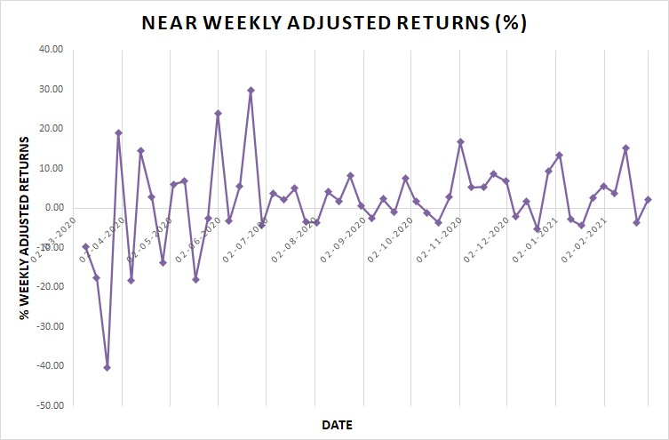

### Next Month

|  |  |  |  |
| --- | --- | --- | --- |
| **Returns(Frequency)** | **Daily** | **Weekly** | **Monthly** |
| **Mean(%)** | 0.3163 | 1.5888 | 11.6686 |
| **Maximum(%)** | 16.3508 | 27.3561 | 25.8928 |
| **Minimum(%)** | -28.7828 | -39.6908 | -4.7614 |
| **Standard Deviation** | 4.8846 | 11.1180 | 9.6044 |

*Table 11: Adjusted Returns for Next Month Futures*

The following graphs show the risk-adjusted returns for Next month CHOLAFIN Futures:

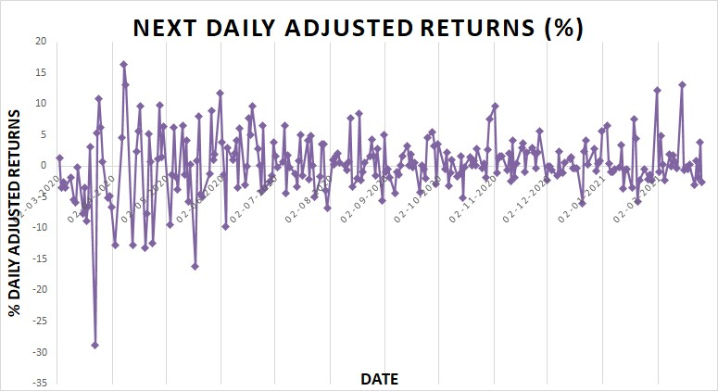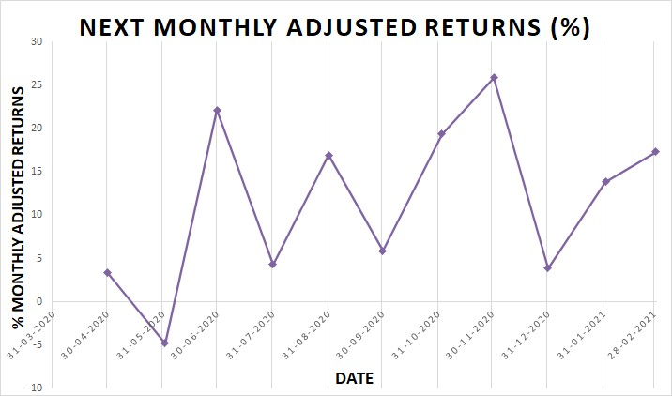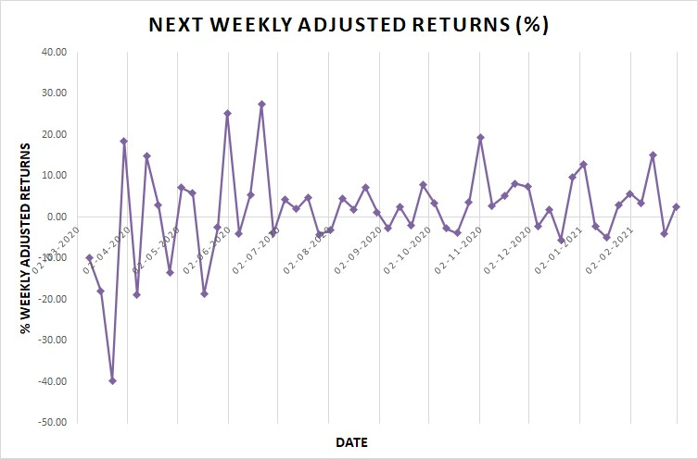

### Far Month

|  |  |  |  |
| --- | --- | --- | --- |
| **Returns(Frequency)** | **Daily** | **Weekly** | **Monthly** |
| **Mean(%)** | 0.3282 | 1.6181 | 11.7768 |
| **Maximum(%)** | 17.0916 | 25.8996 | 27.3743 |
| **Minimum(%)** | -29.9022 | -40.8027 | -4.8077 |
| **Standard Deviation** | 4.9555 | 11.1606 | 9.8325 |

*Table 12: Adjusted Returns for Far Month Futures*

The following graphs show the risk-adjusted returns for Far month CHOLAFIN Futures:

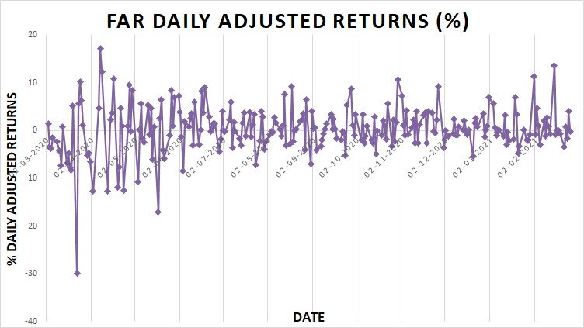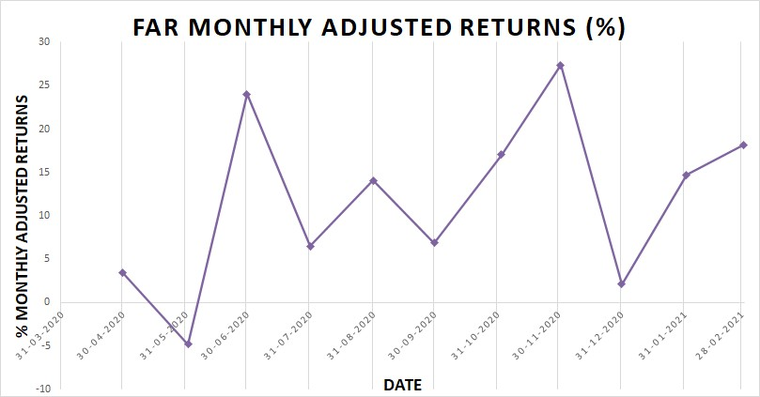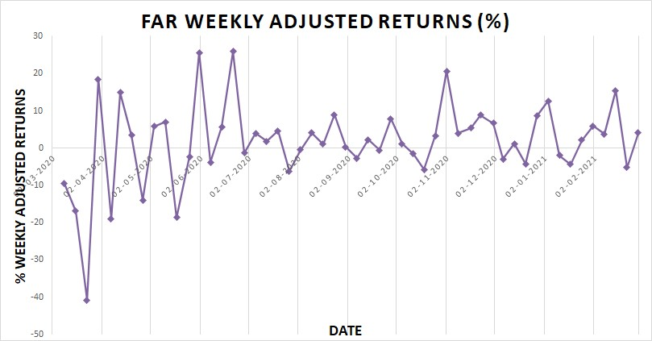

## Risk-Adjusted v/s Unadjusted Returns for Equity Futures Instrument

*\*All the following graphs have been scaled up to 200% to visibly show the difference between the adjusted and unadjusted return values*

### Near Month

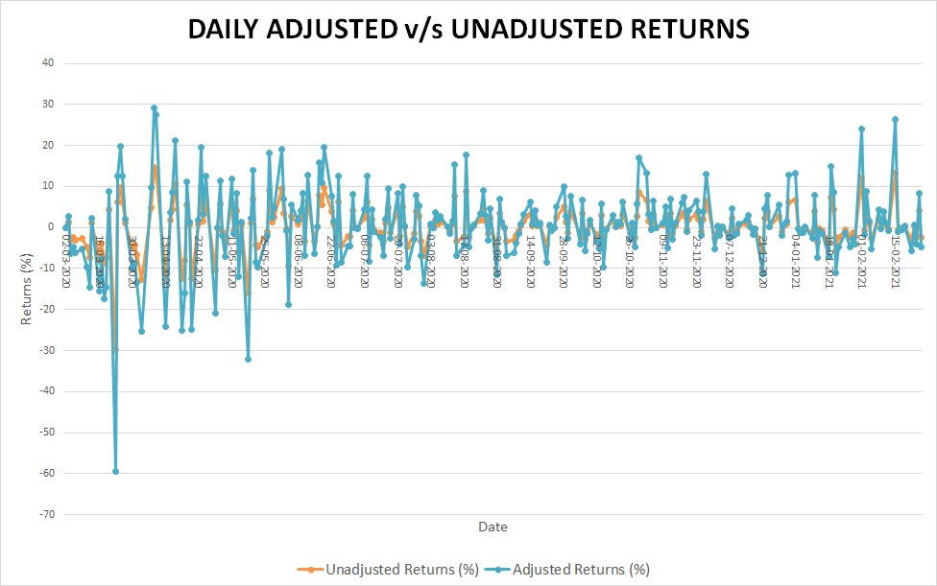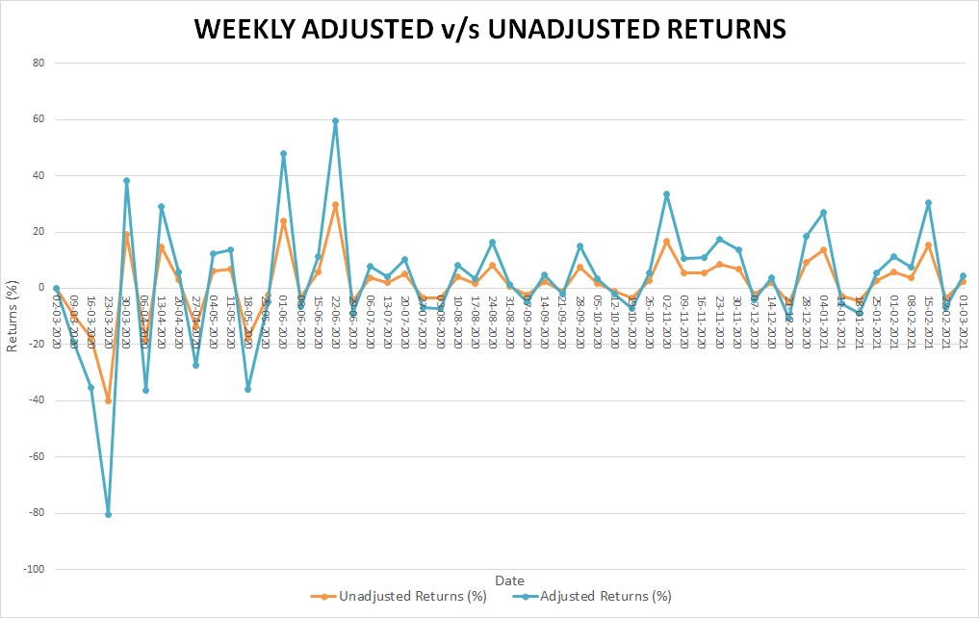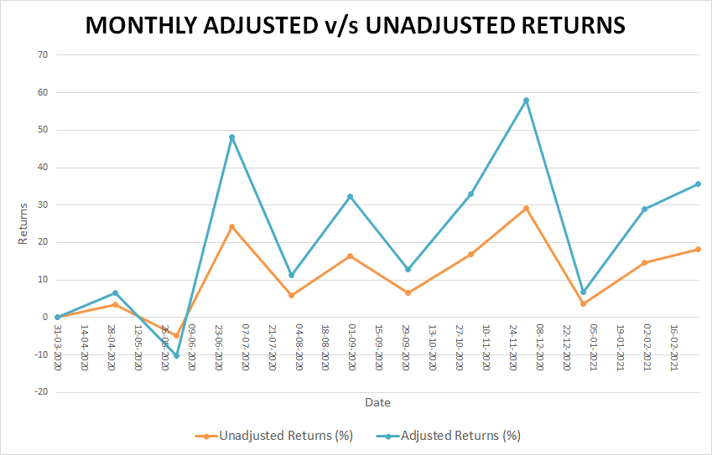

* + 1. **Next Month**

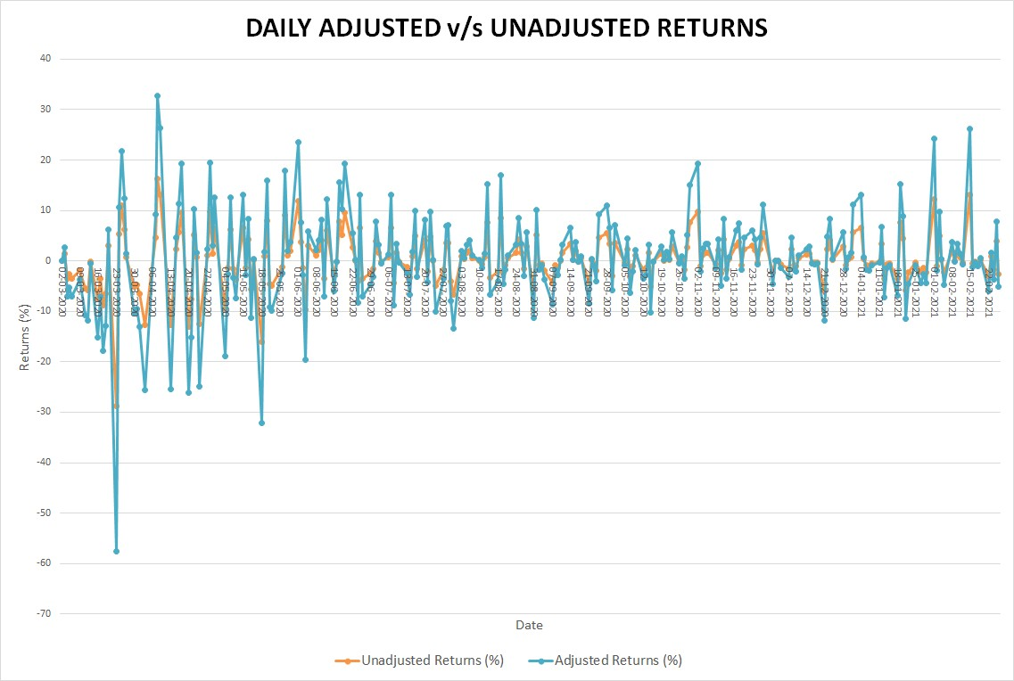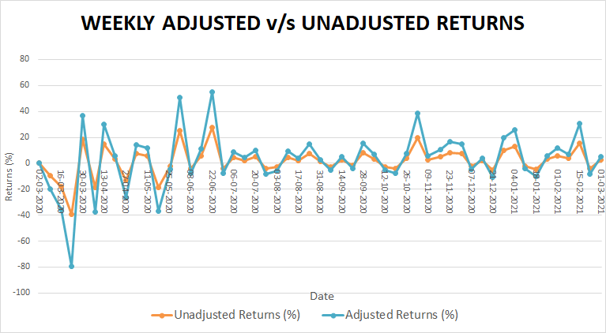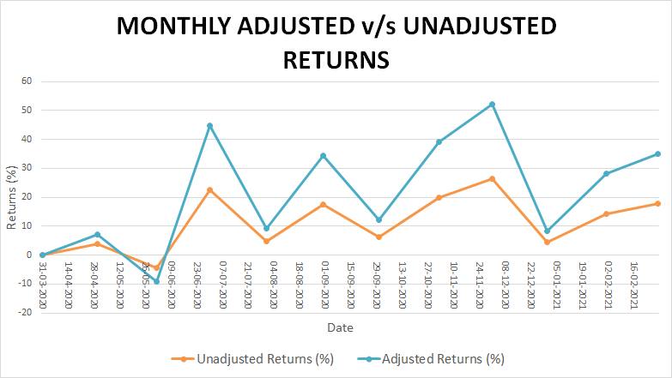

### Far Month

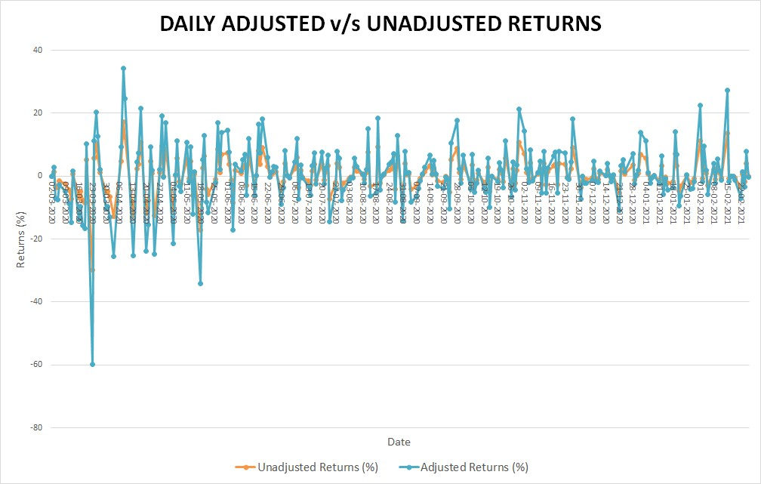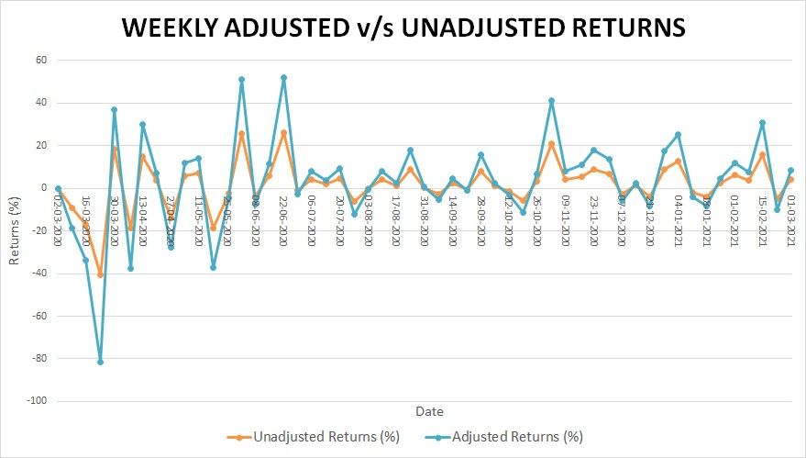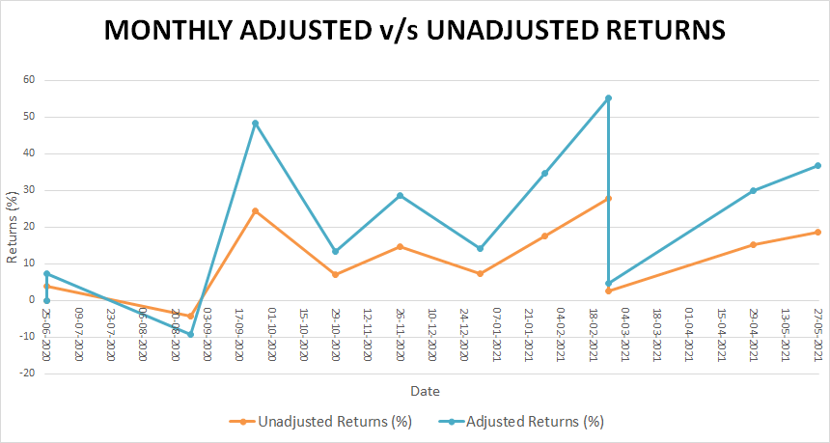

As mentioned in section-1, the risk-adjusted return is a measure of how much return the portfolio gives in excess of the risk-free return, i.e. the T-bill return. Generally, the *Sharpe ratio* indicates the risk-adjusted return, which is defined as the excess return over the risk-free rate relative to the standard deviation of the excess return.

The following tables and graphs show the trend in the Sharpe ratio for different future contract expiry dates and frequencies:

### Near Month

|  |  |  |  |
| --- | --- | --- | --- |
| **Sharpe Ratio (Frequency)** | **Daily** | **Weekly** | **Monthly** |
| **Mean** | 0.0658 | 0.1444 | 1.1577 |
| **Maximum** | 2.9967 | 2.6819 | 2.8405 |
| **Minimum** | -6.1261 | -3.6329 | -0.5246 |
| **Standard Deviation** | 1.0000 | 1.0000 | 1.0000 |

*Table 13: Sharpe Ratio for Near Month Futures*

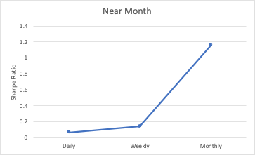

### Next Month

|  |  |  |  |
| --- | --- | --- | --- |
| **Sharpe Ratio (Frequency)** | **Daily** | **Weekly** | **Monthly** |
| **Mean** | 0.0648 | 0.1429 | 1.2149 |
| **Maximum** | 3.3474 | 2.4605 | 2.6959 |
| **Minimum** | -5.8926 | -3.5699 | -0.4958 |
| **Standard Deviation** | 1.0000 | 1.0000 | 1.0000 |

*Table 14: Sharpe Ratio for Next Month Futures*

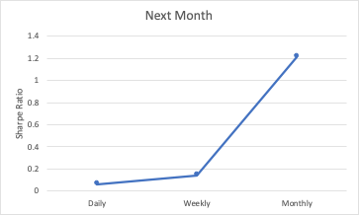

### Far Month

|  |  |  |  |
| --- | --- | --- | --- |
| **Sharpe Ratio (Frequency)** | **Daily** | **Weekly** | **Monthly** |
| **Mean** | 0.0662 | 0.1450 | 1.1977 |
| **Maximum** | 3.4490 | 2.3206 | 2.7841 |
| **Minimum** | -6.0341 | -3.6560 | -0.4890 |
| **Standard Deviation** | 1.0000 | 1.0000 | 1.0000 |

*Table 15: Sharpe Ratio for Far Month Futures*

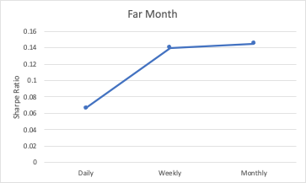

## Economic Interpretation Observations

Comparing on the basis of frequency, we observe:

* The mean risk-unadjusted returns follow the trend: Monthly > Weekly > Daily A similar trend is observed for mean risk-adjusted data.
* However, the standard deviation for both risk-unadjusted and risk-adjusted data follows the Daily < Monthly < Weekly trend.

Thus, this indicates that weekly frequency returns are more volatile than the daily and monthly frequency returns and hence, are riskiest to invest in.

* The positive mean Sharpe ratio indicates that the return on the Futures instrument is expected to be positive, i.e. the firm may generate profits.

On comparing the expiry dates, the following are observed:

* The mean unadjusted returns trend as Next < Near < Far.
* The mean adjusted returns trend as Next < Near < Far.
* The standard deviation (risk) trends as: Next < Near < Far.

## Actions

* Risk loving investors can either aim to take a

1. long position in far month futures. Though the mean returns are highest of all frequencies, the risk associated with these returns is also considerably high; or
2. short position in Far week futures. The risk associated with these returns is the highest, but the return on taking a short position in these contracts is also pretty valuable.

* Risk-averse investors can opt for investment in the spot market rather than the futures market.
* Based on the Sharpe ratio calculations, it is advisable to invest long-term in the CHOLAFIN shares.

## SECTION - 3

### Comparison of Unadjusted & Adjusted Returns

## Unadjusted Returns

|  |  |  |  |  |
| --- | --- | --- | --- | --- |
| **Frequency** | **Equity Shares** | **Equity Futures** | | |
| **Near-Month** | **Next-Month** | **Far-Month** |
| **Daily** | 0.3416 | 0.3358 | 0.3327 | 0.3445 |
| **Weekly** | 0.7163 | 1.7162 | 1.7036 | 1.7307 |
| **Monthly** | 5.3591 | 12.2124 | 12.1649 | 12.2723 |

*Table 16: Unadjusted Returns of Cholamandalam Investment and Finance Company*

## Adjusted Returns

|  |  |  |  |  |
| --- | --- | --- | --- | --- |
| **Frequency** | **Equity Shares** | **Equity Futures** | | |
| **Near-Month** | **Next-Month** | **Far-Month** |
| **Daily** | 0.2050 | 0.3194 | 0.3163 | 0.3282 |
| **Weekly** | 1.6014 | 1.6019 | 1.5888 | 1.6181 |
| **Monthly** | 4.8614 | 11.7160 | 11.6686 | 11.7768 |

*Table 17: Adjusted Returns of Cholamandalam Investment and Finance Company*

* + - * Unadjusted daily returns on average are almost the same for the near month’s futures contract and unadjusted daily returns on the next month futures contract; meanwhile, the daily return on underlying equity returns and far-month futures are nearly similar.
      * Unadjusted weekly returns on average are better for the far month futures contract than the return on the underlying asset; meanwhile, the return on near and next month futures contracts are nearly similar.
      * Unadjusted monthly returns on average are almost identical for the futures contracts (near, next and far months); however, the returns on the far month futures contracts are marginally higher than the other two. Nevertheless, monthly equity returns are not even close to futures contracts.
      * Adjusted daily returns on the far month’s contract are better than adjusted returns on shares and the near and the next months’ futures contracts.
      * The volatility of far month futures daily returns is lower than the volatility of adjusted equity returns. Hence investing in far months’ futures contracts is the best option for risk-taking and risk-avoiding investors.
      * Adjusted weekly returns on the far month futures contract are greater than the adjusted returns on the shares and current month future contract; meanwhile, the next month futures yield slightly less return than others.
      * The volatility of far month futures weekly returns is less than the volatility of adjusted equity returns. Hence risk-loving investors can invest in CHOLAFIN equity shares; meanwhile, investors looking for safer investments can invest in the far month futures contract.
      * Adjusted monthly returns on the far month futures contract are far greater than adjusted returns on the share; meanwhile, the near and next month futures contract yields slightly less return than the far month futures contract.
      * The volatility of monthly equity returns is greater than the futures contracts. Hence, investors looking for high risk and high returns can invest in monthly equity returns.
      * The volatility of monthly returns is least in monthly returns of adjusted next month futures contracts. Hence, risk-averse investors can invest in the next-month futures contract, earning pretty good returns with low risk.

### Liquidity Position

|  |  |  |  |
| --- | --- | --- | --- |
| **Month** | **Near** | **Next** | **Far** |
| **Average No. of Contracts** | 3616 | 533 | 4 |
| **Average Open Interest** | 4993225.8060 | 844708.8353 | 18232.9317 |

*Table 18: Cholamandalam Investment and Finance Company Futures liquidity details*

* For equity shares:

Average daily volume traded: 9064722.45

* It is evident from the daily trading data, considering the average number of contracts and average open interest in the market, that people prefer near-month contracts over the next and far month futures contracts, as near-month contracts give a better liquidity position.
* Hence, even though the far month contracts give better returns than the near and next month, the open interest is heavy towards near- month contracts.

## SECTION - 4

### Contango and Backwardation

Contango and Backwardation are terms used to describe the situation of the futures market based on the difference between the spot price and the futures price of a commodity/ underlying asset.

***Contango*** is a situation where the futures price of a commodity/ underlying asset is greater than the spot price of the commodity, i.e. **Futures price > Spot price**.

When the market/ commodity exhibits a contango behaviour, investors pay more for the stock/commodity in the future. Futures prices being higher than the spot prices may be speculative of prices being higher in the future; thus, a speculator may lock in a profit by buying more future contracts.

***Backwardation*** is a situation where the futures price of a commodity/ underlying asset is less than the spot price of the commodity, i.e. **Futures price < Spot price**.

Backwardation can occur due to a higher demand for an asset currently than the contracts maturing in the future through the futures market.

It is a signal for the investors that the current price is too high, and they can short the asset and buy the futures contract to realise the profit.

\**The below graphs have been calculated on a weekly frequency for all contracts for a clearer picture for the reader.*

### Near Month Futures -vs- Underlying Equity

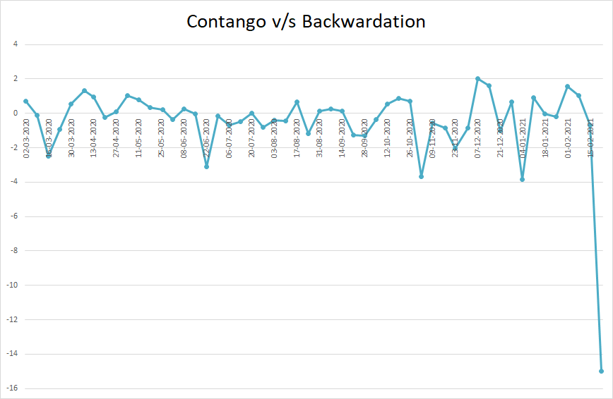

The above graph shows that the excess of the settlement price of near- month futures over the spot price of CHOLAFIN trends more below the zero line, as compared to above the zero line, thus indicating the near month contracts exhibit a ***backwardation*** trend.

### Next Month Futures -vs- Underlying Equity

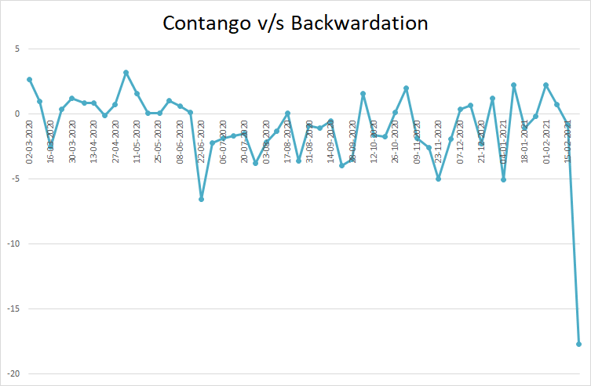

The above graph shows a similar trend as the graph of near-month futures contracts. Thus, the Next- month futures contracts also exhibit a ***backwardation*** trend.

### Far Month Futures -vs- Underlying Equity

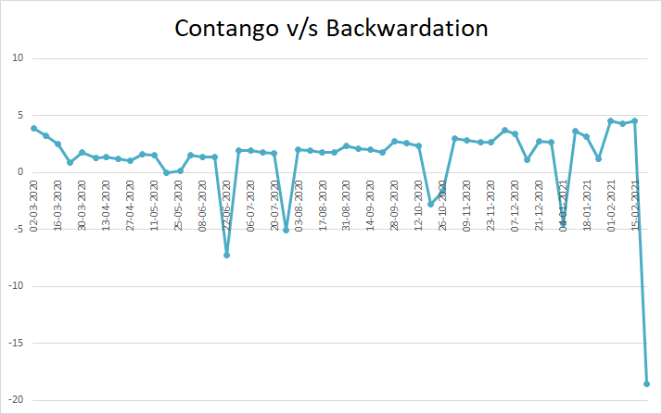

In comparison with the above two graphs, the above graph shows that the excess of the settlement price of far- month futures over the spot price of CHOLAFIN trends more above the zero line, as compared to below the zero line, thus indicating the far month contracts exhibit a ***contango*** trend.

### Significance of Frequency

Economic theories like the Random Walk Theory assume that past movements of a stock price or market cannot be used to predict its future movement.

It considers technical analysis, i.e. study of price and volume of stocks and the frequency of returns, which is undependable.

Nevertheless, it is of utmost importance to investors to realise maximum profits. The frequency of the duration is used to calculate the standard deviation during that period, hence using the Sharpe ratio.

From data of the underlying asset and equity futures, the following observations were made:

* Returns for both the underlying asset and the futures instrument was highest for monthly frequency but with considerable risk.
* Sharpe ratio was the highest for the monthly frequency of the underlying asset and the weekly frequency of near-month futures contracts.

However, since the volatility of weekly Near month contracts is very high, there is a higher risk associated with the investments.

Thus, for risk-averse investors, the best strategy would be to invest and hold the CHOLAFIN stock, while for risk-taking investors, the best strategy would be to take a long position in Near weekly contracts.

## SECTION - 5

### 5.1 Conclusion

From the above analysis, it is apparent that investing in the Far month monthly contracts has yielded the maximum profits, whereas the underlying equity daily contracts have performed the worst. As far as risk is concerned, underlying equity monthly contracts are the riskiest of all, whereas Next month daily contracts are the safest ones to invest in.

The mean returns for all the frequencies are positive for underlying equity assets and equity futures instruments, which is a favourable condition for an investor. According to analysts’ reports, Cholamandalam Investment and Finance has the potential to yield greater returns in the next three years.

However, the firm is expected to grow at 26.7 %, which is lower than the industry average of 34.2%. Thus, it makes the firm unpromising for an investor to invest in its equity/futures instruments.

Thus, the trustworthiness is not very high and is also evident by the deficient proportion of shares held by the general public and government. Moreover, the returns were also highly volatile throughout the observation.

However, investors can consider investing in this firm upon critical observation of historical data and the analysts’ predictions.

# SECTION 6

### References

* + - <https://en.wikipedia.org/wiki/Cholamandalam_Investment_and_Finance_Company>
    - <https://www.cholamandalam.com/files/MEDIA/Annual-Reports-2019-2020.pdf>
    - <https://www.cholamandalam.com/>
    - [https://economictimes.indiatimes.com/cholamandalam-investment-finance-company-](https://economictimes.indiatimes.com/cholamandalam-investment-finance-company-ltd/stocks/companyid-12159.cms) [ltd/stocks/companyid-12159.cms](https://economictimes.indiatimes.com/cholamandalam-investment-finance-company-ltd/stocks/companyid-12159.cms)
    - [https://finance.yahoo.com/news/cholamandalam-investment-finances-nse-cholafin-](https://finance.yahoo.com/news/cholamandalam-investment-finances-nse-cholafin-012614978.html) [012614978.html](https://finance.yahoo.com/news/cholamandalam-investment-finances-nse-cholafin-012614978.html)
    - <https://www.investopedia.com/terms/s/sharperatio.asp>